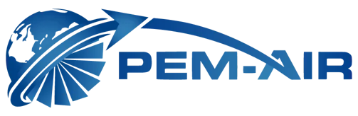
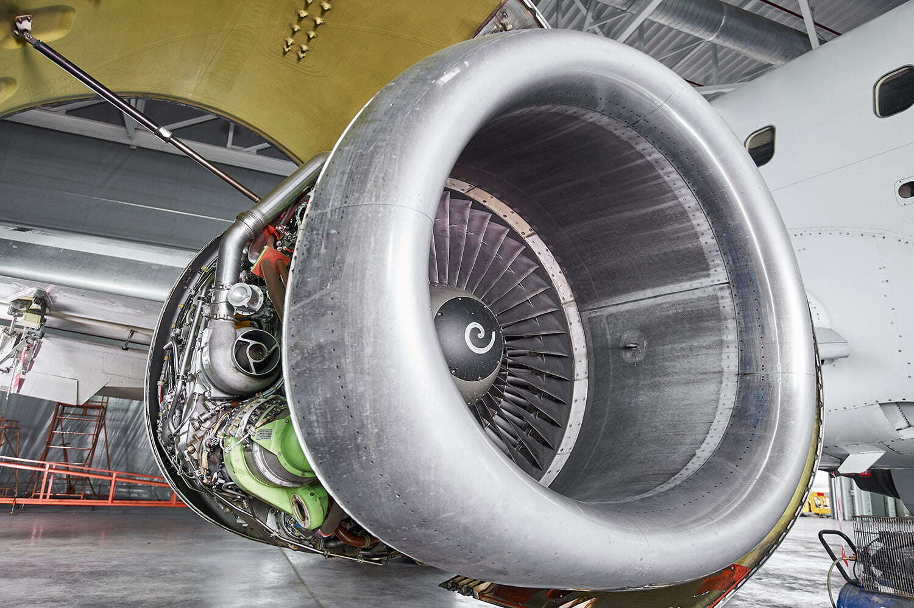
Company Profile
Turbine Engine MRO • Field & AOG • Engine Testing • Component Services • Engine Leasing & Trading
Brooksville, Florida (Engine Services) | Davie, Florida (Component Services)
December 2025

Contents
1. Company Overview
2. Capabilities & Services
3. Engine Capability Portfolio
4. Facilities & Capacity
5. Quality, Compliance & Certifications
6. Technical Excellence & MRO Approach
7. Contact Information
8. Appendices (Certificates & Presentation)

1. Company Overview
PEM-AIR provides integrated turbine engine maintenance, repair and overhaul (MRO), field and AOG support, engine testing services, and FAA/EASA-certified aircraft component repair. With operations dating back to 1980 and turbine engine services active since 2013, PEM-AIR combines decades of experience with modern infrastructure to deliver dependable, responsive, and cost-efficient solutions for operators, lessors, and asset owners.
Founded | 1980 (PEM-AIR Component Services); turbine engine services active since 2013
Locations | Brooksville, Florida (Engine Services) • Davie, Florida (Component Services)
Certifications | FAA Part 145 Repair Stations • EASA Part 145 approvals • UK CAA approval • ISO 9001:2015 (Component Services)
Core services | Engine MRO & performance restoration • Field & AOG • Engine testing • Component repair (Class 1/2/3) • Leasing & trading
Capacity highlights | 80,000 sq. ft. new engine facility (opened 2024) • 20+ engine bays (expandable) • 25 component test stands • 1,100+ component capabilities
Always-on support | 24/7/365 AOG response (aog@pem-air.com) and coordinated field deployments worldwide
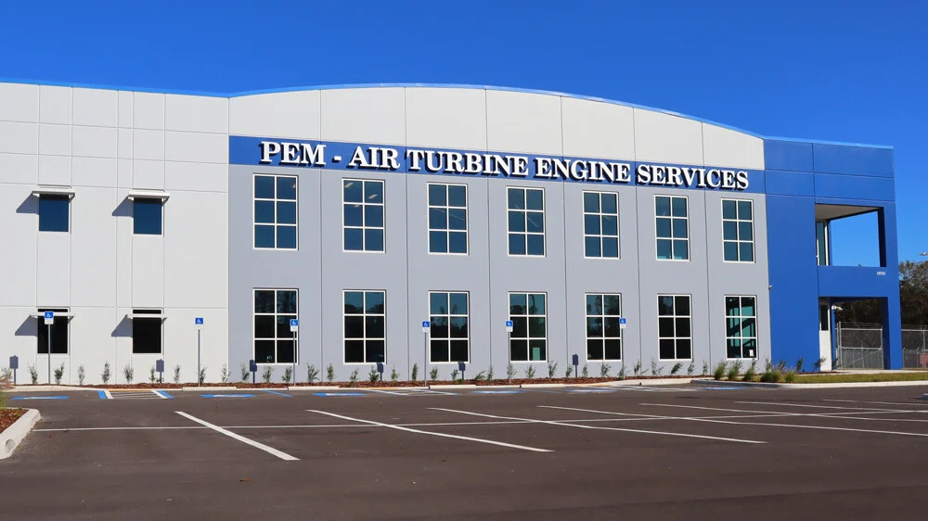
PEM-AIR’s next-generation engine services facility (Brooksville, FL)
Our values
 |  |  | 
Experience  Highly skilled leadership and technicians with deep turbine and component MRO backgrounds. | Quality  Disciplined processes, regulatory compliance, and a right‑first‑time culture focused on reliability. | Technical Expertise  Workscope flexibility—supporting legacy and current engines through repair, restoration, and overhaul. | Customer Focus  Responsive planning, transparent coordination, and rapid AOG support when it matters most.
Experience & Customer Partnership
PEM-AIR’s teams include FAA-licensed technicians and an integrated mix of experienced commercial and former military personnel. The company partners closely with operators and asset owners to tailor workscope, manage risk, and maintain transparency—especially during AOG events and time-critical returns to service.
- Workscope flexibility: from minimal‑penetration maintenance through performance restoration and overhaul
- Integrated engine + component capability to reduce subcontracting and accelerate turnaround
- Responsive coordination and documentation discipline aligned to regulatory and lessor requirements
- Practical engineering and troubleshooting support focused on safe, reliable outcomes
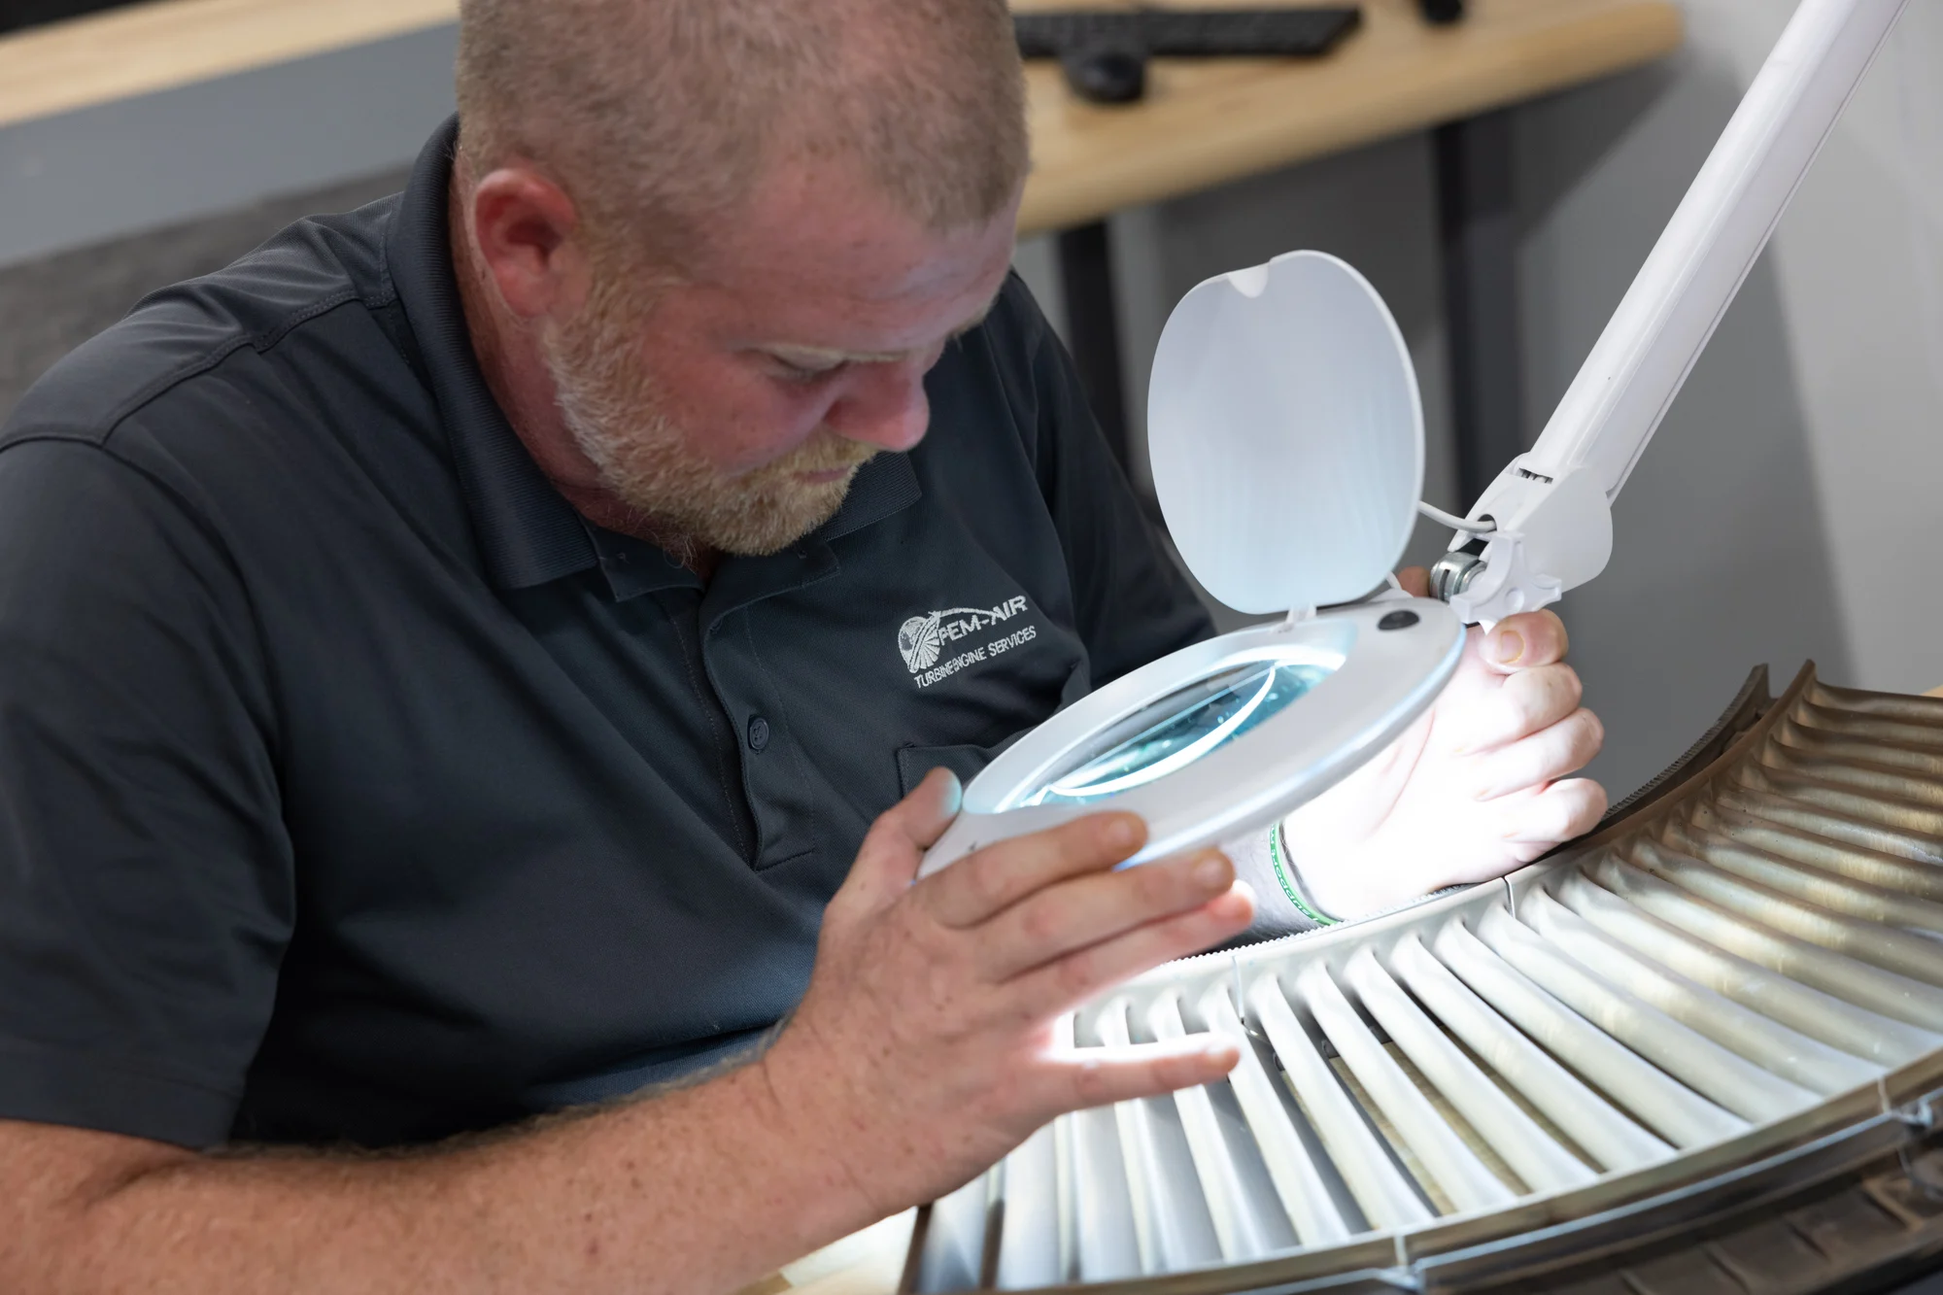
Precision inspection and quality assurance in turbine engine maintenance

2. Capabilities & Services
PEM-AIR supports customer needs across the full maintenance spectrum—from rapid field response and targeted performance restoration through shop visits and full overhaul. Integrated capabilities help reduce downtime, control cost, and maintain high standards of safety and compliance.
2.1 Turbine Engine MRO & Performance Restoration
PEM-AIR supports all levels of work scope, including maintenance, repair, overhaul (MRO), and performance restoration for a broad range of turbofan engines.
Workscope strengths include:
- Flexible work scopes: targeted repairs, performance restoration, and full shop visits
- Module and LRU changes, troubleshooting, and corrective actions
- Engine management support including compliance with Airworthiness Directives (AD) and Service Bulletins (SB)
- Planning discipline aligned to operator schedules and lessor return conditions
Selected engine services include:
- Airworthiness Directive (AD) and Service Bulletin (SB) compliance services
- Engine removal and installation coordination
- Engine test cell runs (as required) and on‑wing testing / MPA support
- Borescope and NDT inspection; troubleshooting engine performance
- Boro‑blending (gas path damage blend repairs, where applicable)
- VSV/VBV static rigging
- Module changes including LPT, BOOSTER, and HPT modules (as applicable)
- Top case and bottom case changes (as applicable)
- Engine preservations
- QEC swaps and QEC conversions
- Fan disk and blade changes (as applicable)
- LRU replacement
- Main gearbox, AGB, and TGB replacements (as applicable)
- AOG support worldwide and FAA/EASA dual release capability
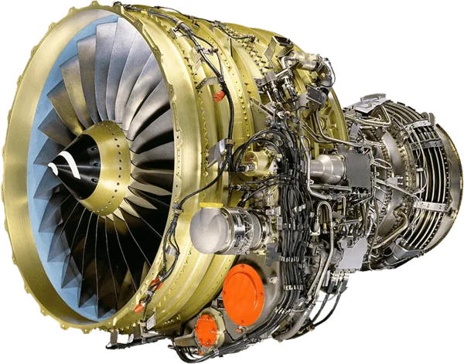
Supported engine families include legacy and current commercial turbofan platforms
2.2 Field & AOG Services (24/7/365)
AOG events demand fast, safe, and effective action. PEM-AIR provides on‑wing support and field maintenance to mitigate disruptions and return aircraft to service quickly.
- Worldwide AOG support available 24/7/365
- On-wing repair solutions and field troubleshooting
- Hospital visits and performance restoration work scopes
- Coordination support for engine removal/installation and logistics
AOG contact: aog@pem-air.com
2.3 Engine Testing Support
PEM-AIR performs on‑wing testing and Maximum Power Assurance (MPA) runs for most engine types. Services can be performed in the field or at the Brooksville (BKV) facility when aircraft are flown in.
- MPA checks to verify thrust capability
- Balance and vibration measurement and corrective balancing support
- Oil and fuel system tests and leakage checks
- Off‑wing test procedures coordinated through established off‑site test cell partner network when required
Dedicated GE‑powered 767 aircraft supports real‑time engine testing as shop work completes.
On-wing testing and post‑maintenance verification
2.4 Aircraft Component & Accessory Services
From its Davie, Florida facility, PEM-AIR provides FAA and EASA-certified component and accessory maintenance under an FAA Part 145 Unlimited – Class 1, 2, and 3 rating. The component shop offers over 1,100 capability listings and specializes in fuel, electric, hydraulic, pneumatic, oil, and electromechanical systems.
- 25 in-house test stands supporting component and accessory repair and overhaul
- Custom packaging and 3D‑printed protective covers to protect hardware in transit
- Integrated component repair capability supporting engine programs and teardown/asset services
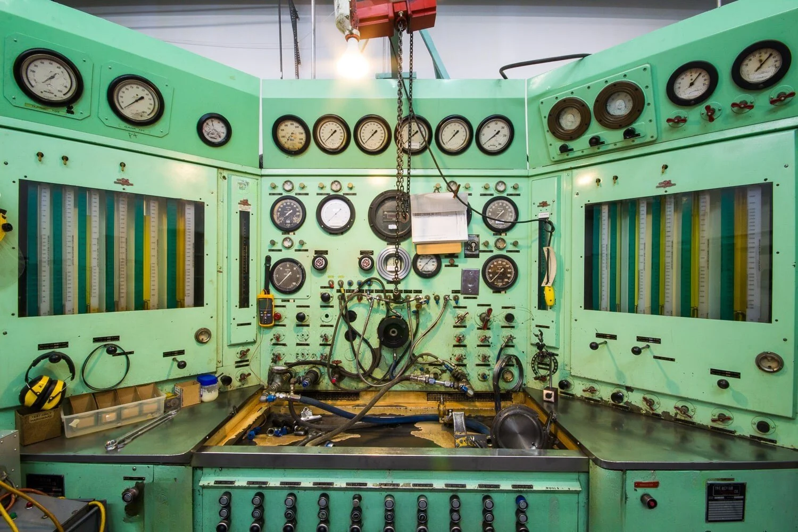 | 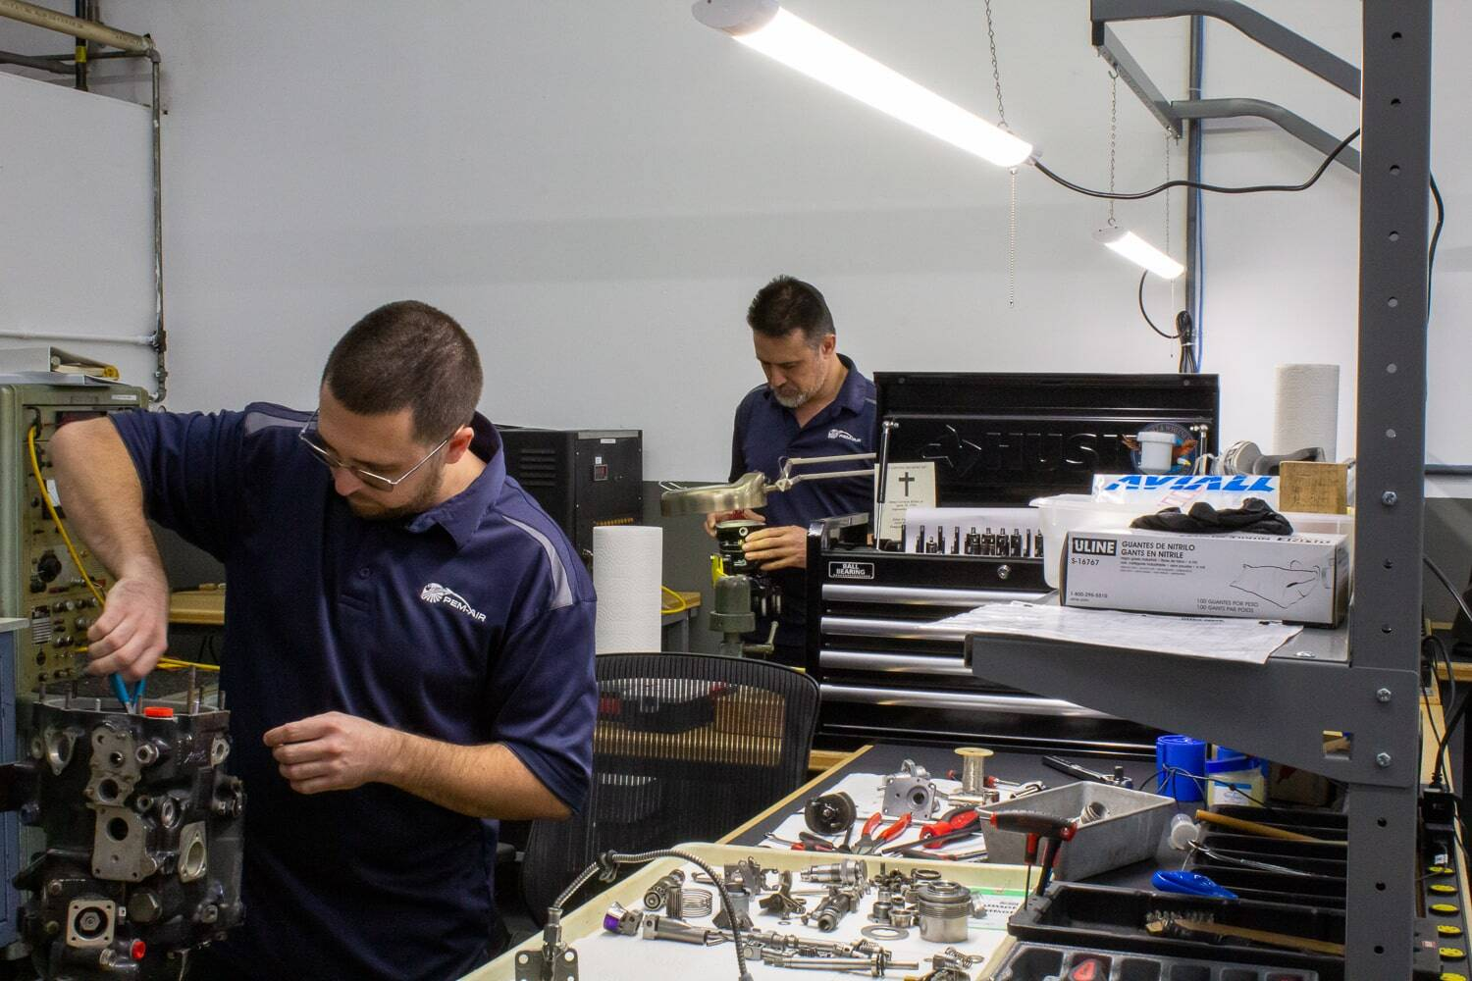

2.5 Engine Leasing & Trading
To support fleet continuity and recovery planning, PEM-AIR provides engine leasing and trading solutions structured for flexibility and cost efficiency.
- Wet/dry leases and short‑term leases
- Green‑time leases, pooling, and exchange programs
- Sale/leaseback, remarketing, and asset management support
- Operating and financial leases, sales, and forward purchases
2.6 Aircraft Storage, Teardown, Disassembly & RTS
In addition to MRO shop and on‑wing maintenance, PEM-AIR offers aircraft parking, storage, return‑to‑service (RTS) maintenance support, and aircraft disassembly/part‑out services.
- End‑to‑end support for teardown and recycling projects with in‑house component repair capability
- Care‑of‑maintenance programs supported under FAA Part 145 certification to support storage decisions and redelivery planning
- Support for both narrow‑body and wide‑body aircraft at competitive rates
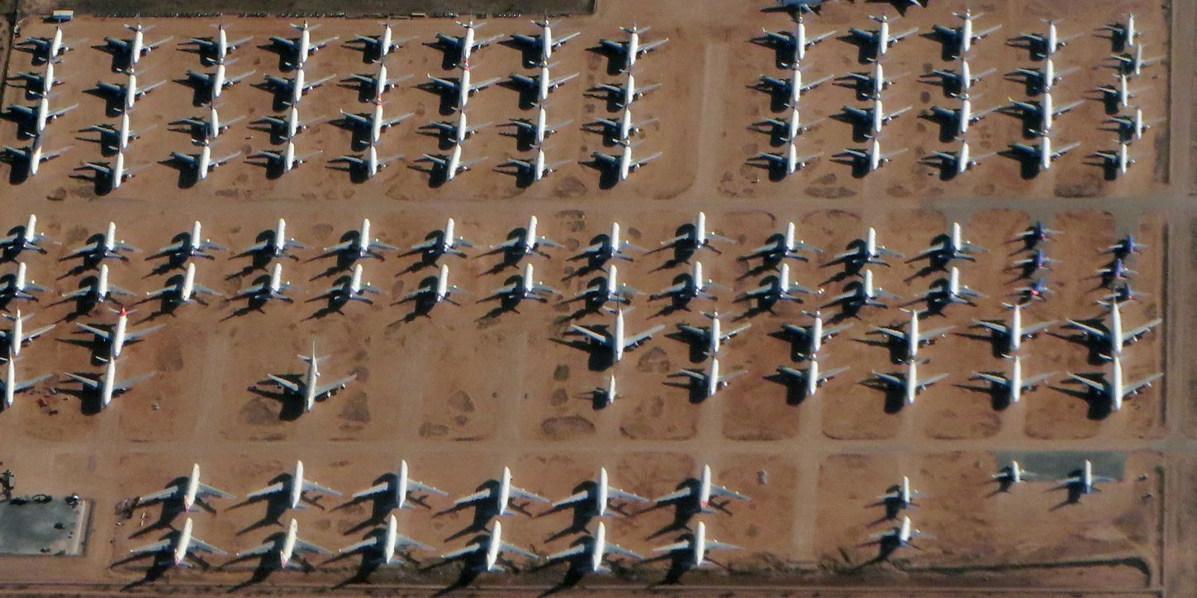 | 
2.7 Lessor Partnerships & Asset Support
PEM-AIR supports lessors and asset owners with flexible maintenance strategies, disciplined documentation practices, and workscope planning designed to protect asset value while meeting operational needs.
2.8 Military & Public Use Aircraft Projects
In addition to commercial fleets, PEM-AIR supports Military Commercial Derivative Aircraft (MCDA) platforms and other public-use projects through engine and component repair support and related services.

3. Engine Capability Portfolio
PEM-AIR supports legacy and current turbofan engine families and variants across major OEM lineages. For the latest scope, approvals, and release-to-service details applicable to your engine and workscope, coordinate with PEM-AIR technical sales and quality teams.
Engine Manufacturer | Models / Variants
CFM International | CFM56-2 / -3 / -5 / -7
Engine Alliance | GP7200 (GP7268 / GP7270 / GP7277)
GE Aerospace | CF34-3 / -8 / -10; CF6-50 / -80; GE90
International Aero Engines (IAE) | V2500
Pratt & Whitney | JT3D / TF33; JT9D; PW2000/F117; PW4000; PW1100G-JM (PW1100)
Rolls-Royce | RB211; Trent 700 / 800 / 900 / 1000
All work is performed in accordance with applicable regulatory approvals and customer requirements.

4. Facilities & Capacity
PEM-AIR has expanded infrastructure and materials readiness to support higher throughput, larger engine platforms, and responsive AOG field support.
4.1 Brooksville, Florida – Turbine Engine Services
The Brooksville facility provides full-service engine maintenance, repair, overhaul, and performance restoration. In 2024, PEM-AIR opened a new 80,000 sq. ft. state‑of‑the‑art facility designed to support a broad range of engine platforms—including larger GE90 and Trent 800 turbofans.
- 80,000 sq. ft. new facility (opened 2024)
- Approximately 8× increase in capacity compared to prior footprint
- 20+ engine bays with potential expansion up to 35 bays depending on configuration
- Large inventory of engine materials and expendables to support quoted lead times
Brooksville engine services campus
4.2 Additional Brooksville Facilities
In addition to the new facility, PEM-AIR maintains legacy facilities in close proximity dedicated to work scopes requiring special consideration, including certain military or government operated fleet programs, as well as dedicated storage and warehousing spaces.
4.3 Davie, Florida – Component Services
The Davie facility is home to PEM-AIR’s component services operations—featuring 25 test stands and extensive component repair capability supporting commercial and government-operated platforms.
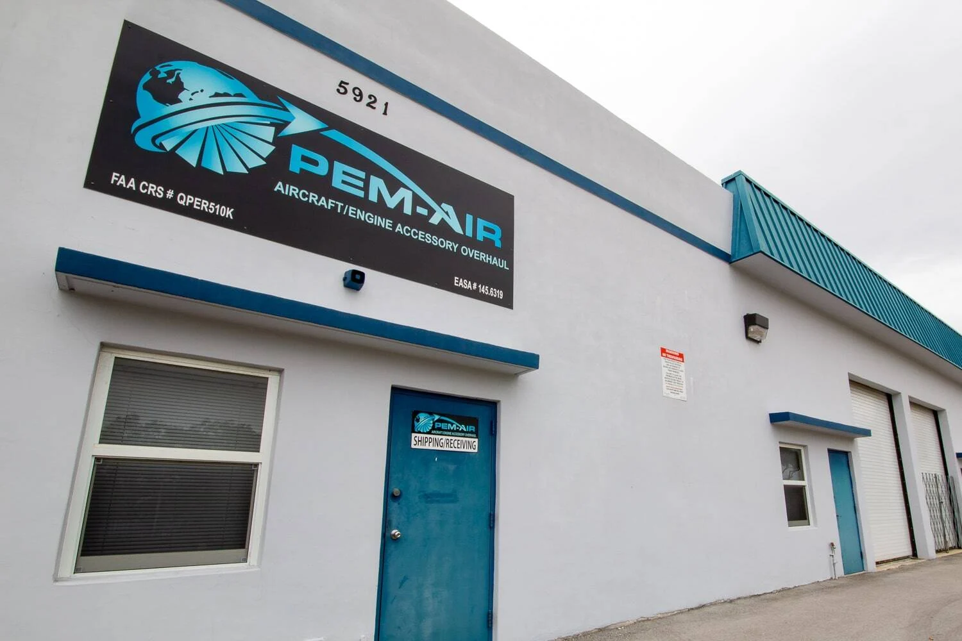
Davie component services facility

5. Quality, Compliance & Certifications
Quality assurance is central to PEM-AIR operations. The company maintains FAA Part 145 repair station certifications and EASA approvals for both turbine engine and component services. PEM-AIR also holds UK CAA approval for engine services and maintains an ISO 9001:2015 certified quality management system for component services.
Certification and compliance highlights include:
- FAA Part 145 repair station approvals supporting engine and component work scopes
- EASA Part 145 approvals supporting engine and component services
- UK CAA approval supporting engine services
- FAA/EASA dual release capability for applicable work scopes
- ISO 9001:2015 certified quality management system for component services
Quality and compliance are at the core of PEM-AIR operations
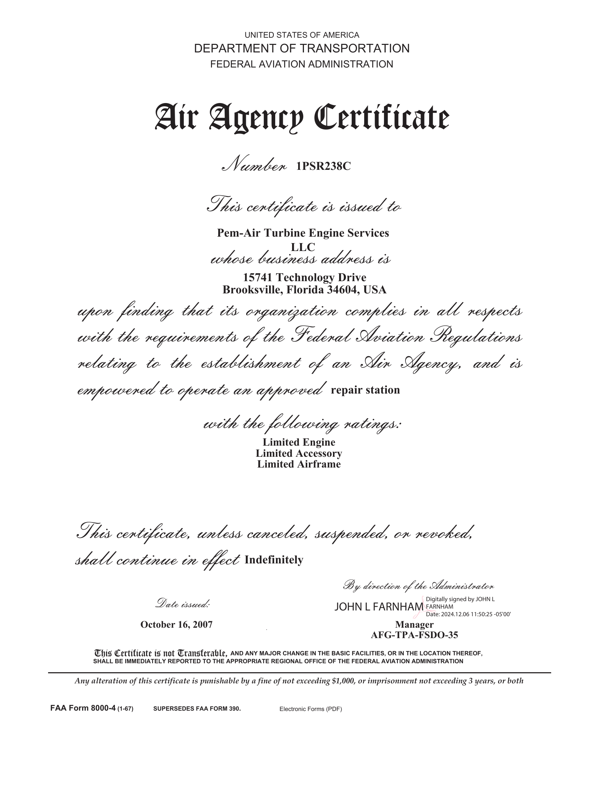 | 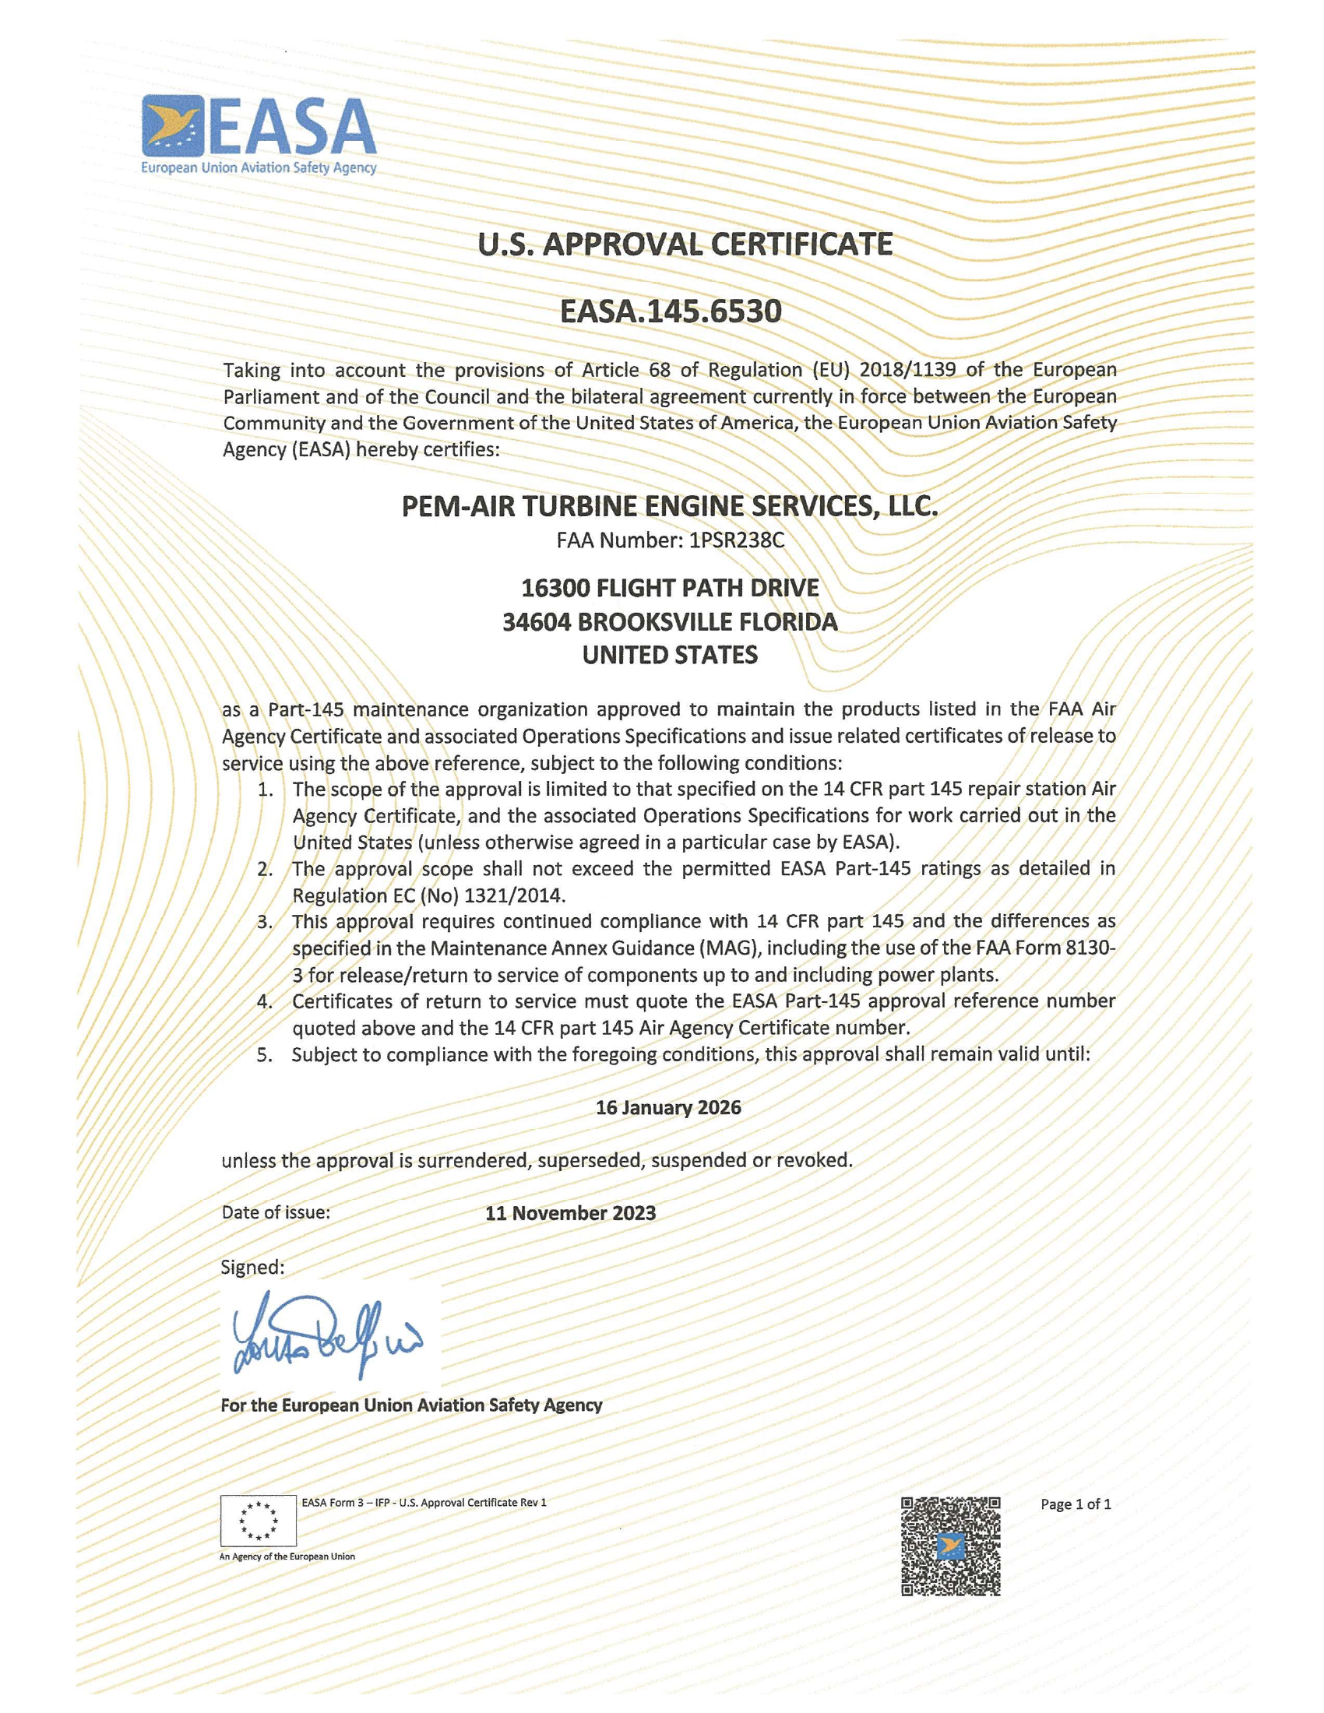
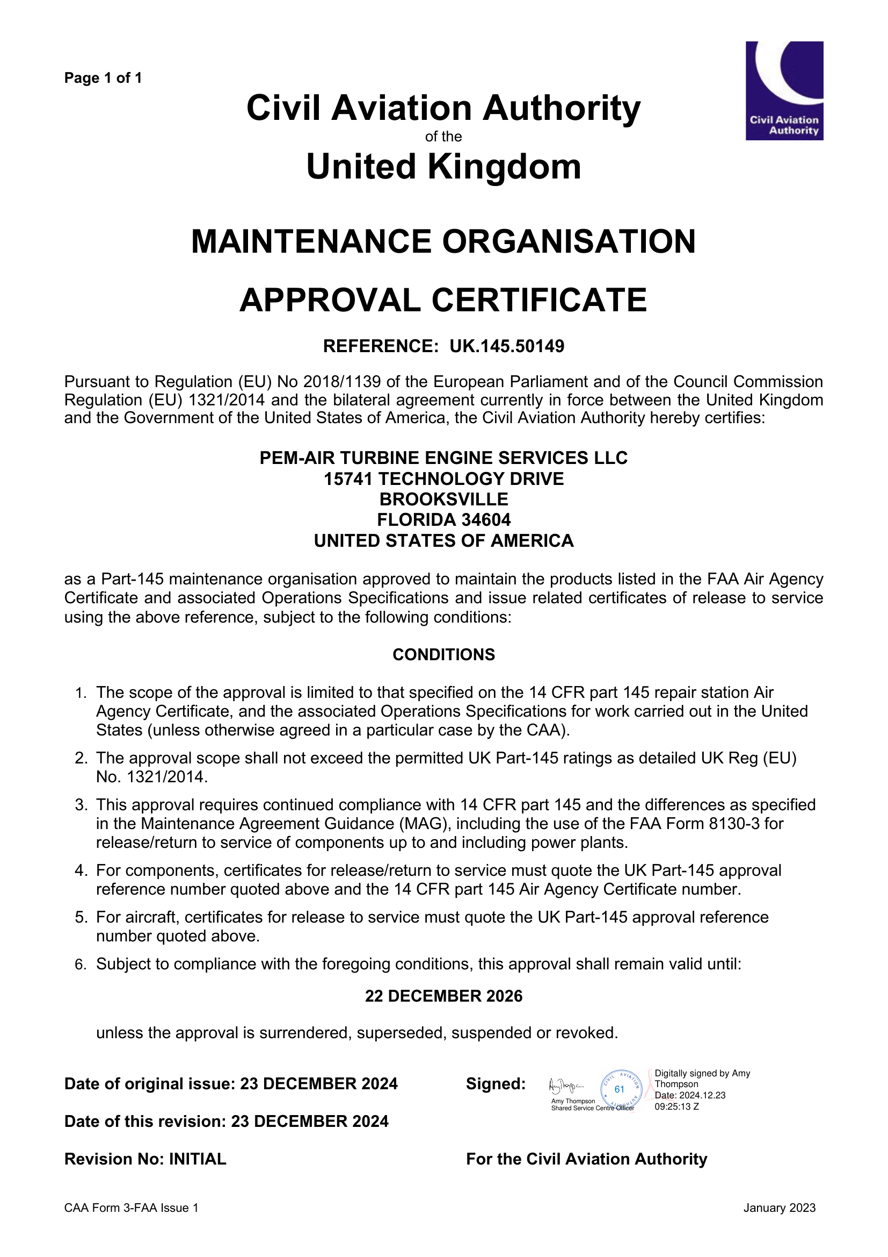 | 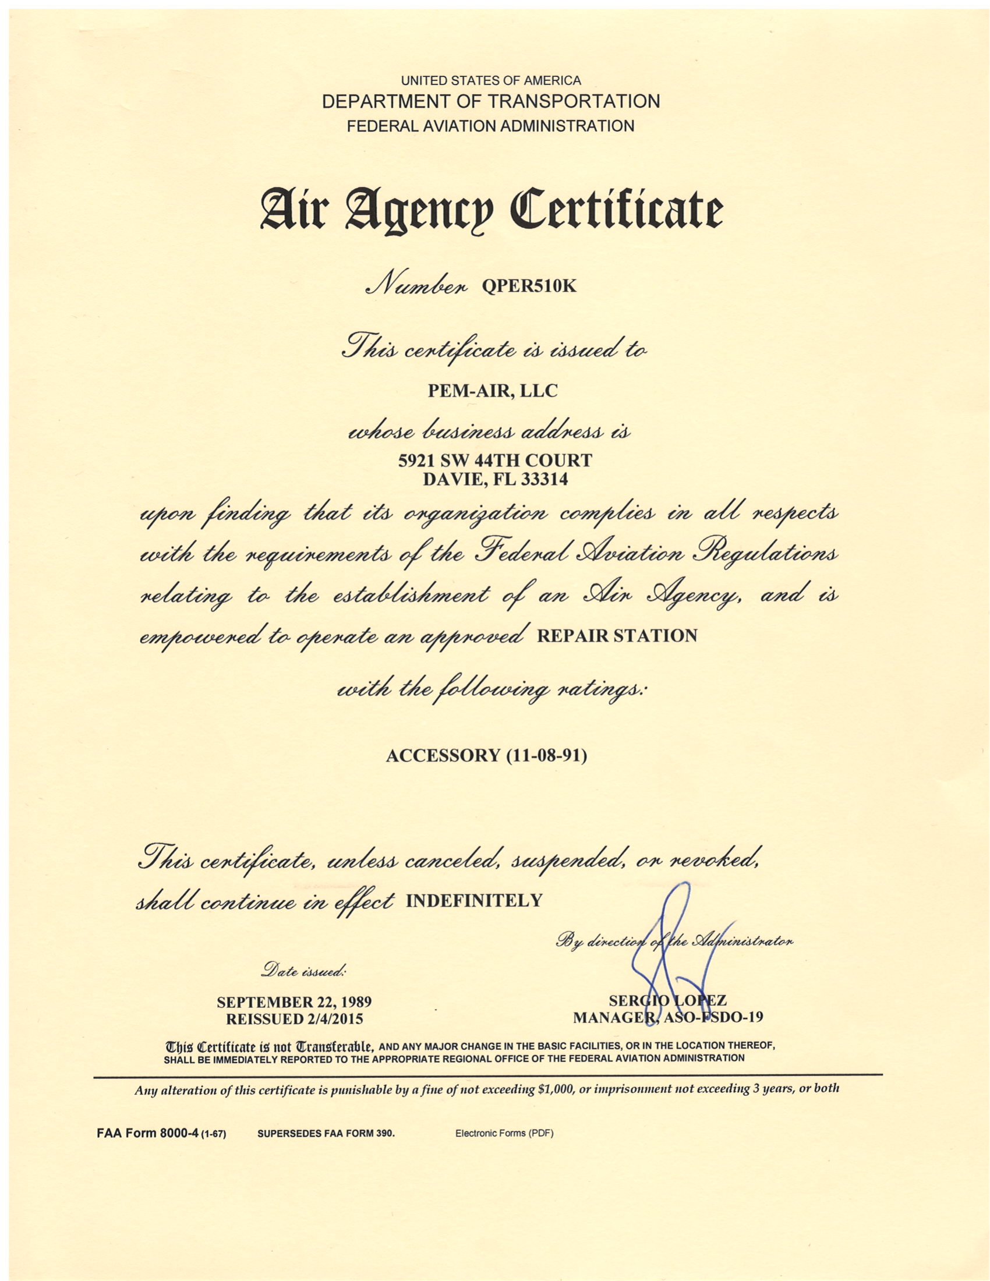
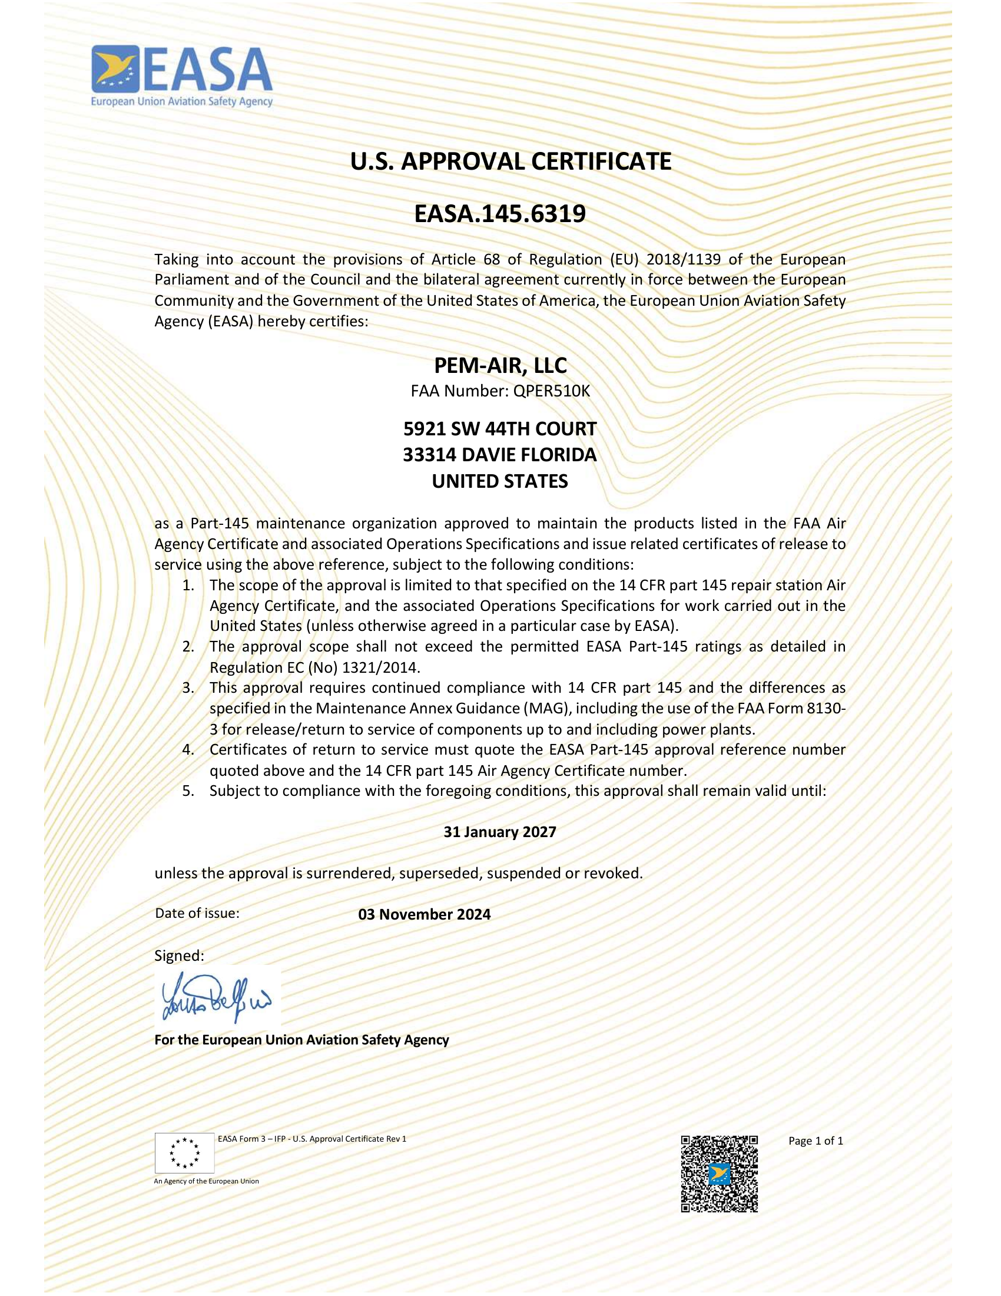 | 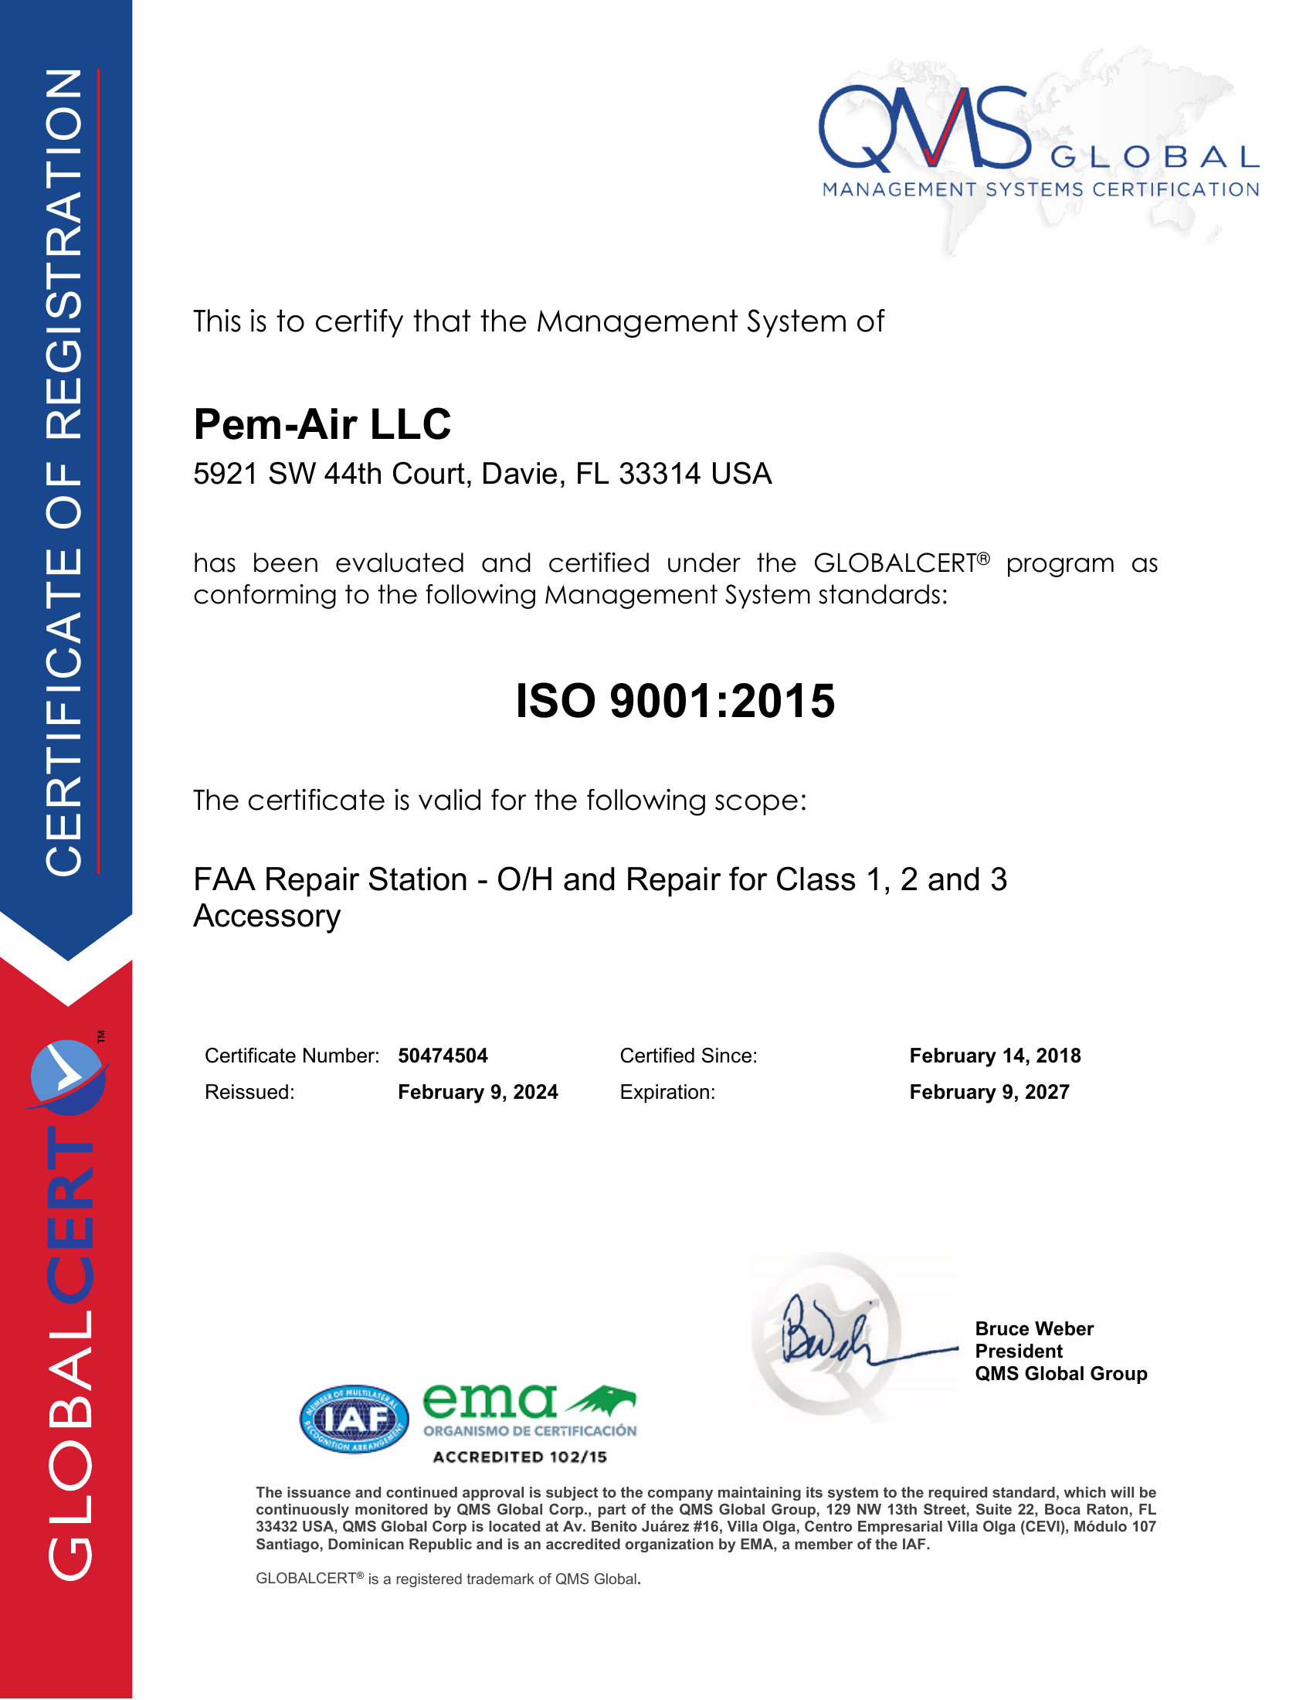
Full-size certificate copies are provided in the Appendices.

6. Technical Excellence & MRO Approach
Modern turbine engine maintenance demands disciplined inspection, repeatable processes, and meticulous documentation. PEM-AIR’s approach blends practical field experience with a structured MRO workflow to help customers manage reliability, performance, and cost.
6.1 End-to-End Maintenance Lifecycle
A typical engine event integrates induction planning, disassembly, cleaning, inspection, repair, reassembly, testing, and release-to-service documentation. PEM-AIR aligns these steps to reduce turnaround time while maintaining compliance and traceability.
Induction & Planning | Disassembly | Cleaning | Inspection | Repair & Overhaul | Reassembly | Test & Release
Records review, workscope definition | Module separation and hardware control | Preparation for inspection and repair | Borescope, digital measurement, NDT | Approved repairs, module changes, AD/SB | Rigging, torque, dimensional control | MPA / balance checks; documentation
6.2 Field Maintenance Technical Features
Field maintenance and hospital visit scopes often focus on recovering performance quickly and safely. Typical technical elements include borescope inspection, gas path restoration, VSV/VBV rigging, rotor balancing support, and targeted LRU/module changes.
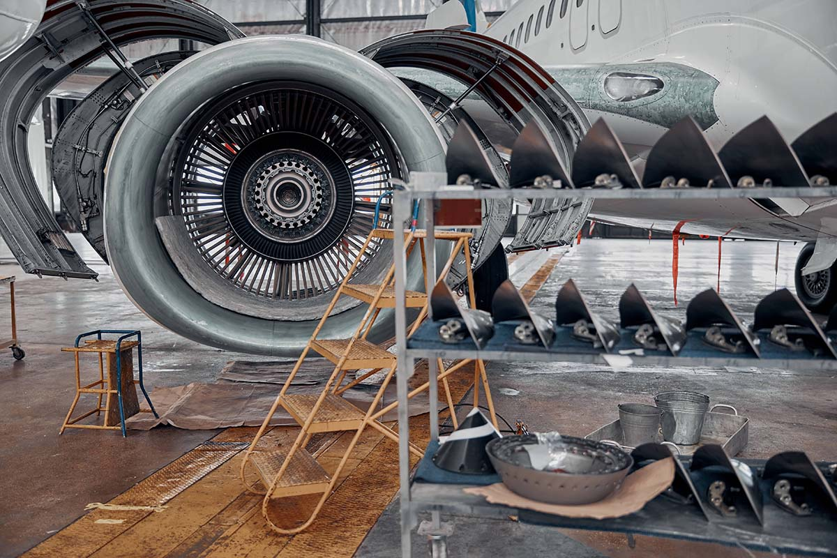
Field execution supports rapid, controlled return-to-service outcomes
6.3 Testing, Verification & Reliability Focus
On-wing testing and MPA runs verify thrust capability and can detect balance, vibration, or systems issues. Verification activities reduce risk after maintenance events and support dependable service entry.
Verification and testing support safety and reliability
6.4 Component Protection & Handling Discipline
Protection during transport and handling reduces risk of rework and improves reliability outcomes. PEM-AIR supports component integrity with custom packaging solutions—including 3D‑printed protective covers—plus extensive in‑house test stand capability.

7. Contact Information
For quotations, technical coordination, or additional information, please contact PEM-AIR:
Main phone | +1 (352) 663-8688
Fax | +1 (954) 321-8998
Service email | service@pem-air.com
AOG support email | aog@pem-air.com
Websites | pem-air.com • pem-airturbine.com
Turbine Engine Services (Brooksville, FL) | 15741 Technology Drive, Brooksville, Florida 34604, USA
Component Services (Davie, FL) | 5921 SW 44th Court, Davie, Florida 33314, USA
This profile is compiled from PEM-AIR published materials and certificates. For the latest capability scope and approvals, please contact PEM-AIR directly.

8. Appendices (Certificates & Presentation)
8.1 Certifications – Full Copies
FAA Engine Repair Station Certificate

EASA Part 145 Approval – Engine

UK CAA Part 145 Approval – Engine

FAA Unlimited Class 1/2/3 – Components & Accessories

EASA Part 145 Approval – Components & Accessories

ISO 9001:2015 – Component Services

8.2 Engine MRO Presentation (Attachment)
The following pages reproduce the provided PEM-AIR Engine MRO presentation as an integrated appendix.
